**Termination (Not Eligible to Retire- Vested)**

*Retirement Rules: Normal retirement age for a general member is 65 and a designated member is 60*

*Early retirement: Unreduced and Reduced*

*Unreduced retirement for general member: Age + Eligibility service not less than 80*

*Reduced retirement for general member: Age=55, Eligibility service at least 15 years*

*Unreduced retirement for designated member: Age + Eligibility service not less than 75 or Age=55 or Eligibility service =25*

*Reduced retirement for designated member: Age + Eligibility service not less than 70 or at Age=45*

Vested member: Members with vesting service greater than 2 years

Step 1: Search for an Active vested member who is not eligible to retire (Normal retirement or early retirement)

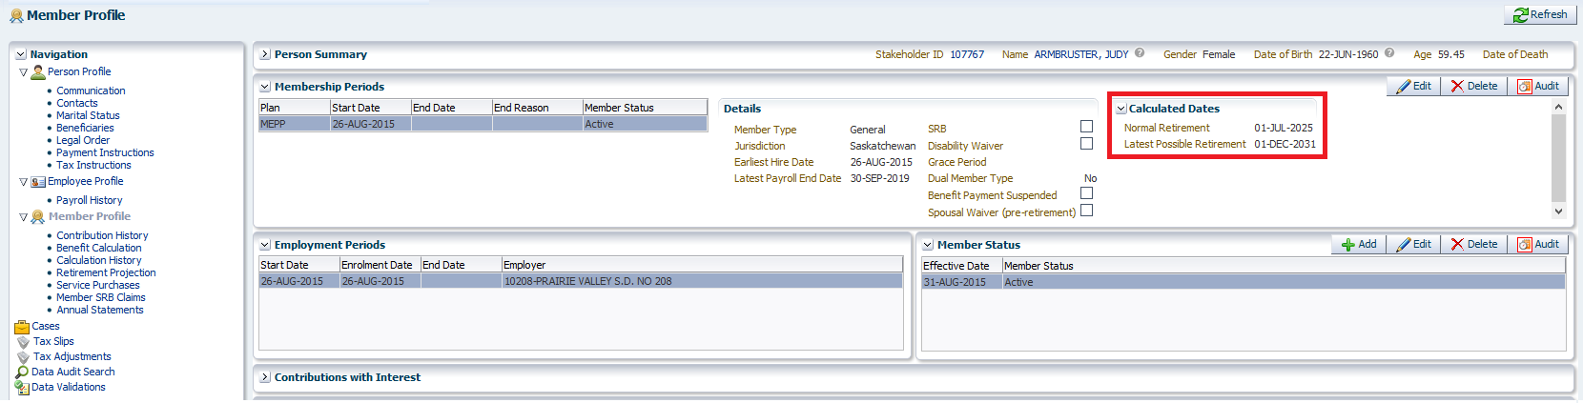

*The member is not eligible for retirement*

Step 2: Navigate to employee profile, end the employment by clicking on the Edit button under Employment Periods tab.

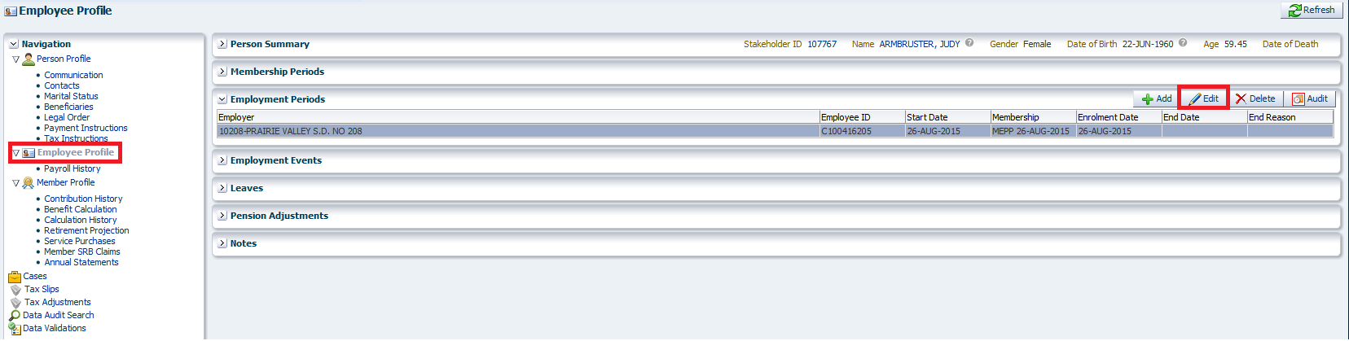

Step 3: Enter the end date and reason as termination and hit the save button

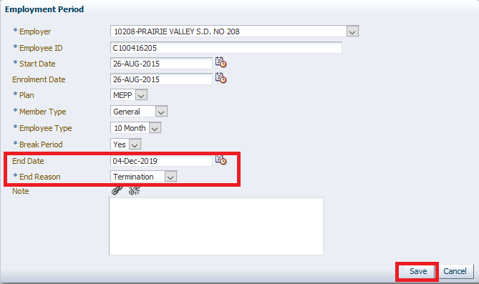

*Termination date should be the date at which the final contribution was received*

Step 4: Add the payment instructions by clicking payment instruction tab and hit Add button

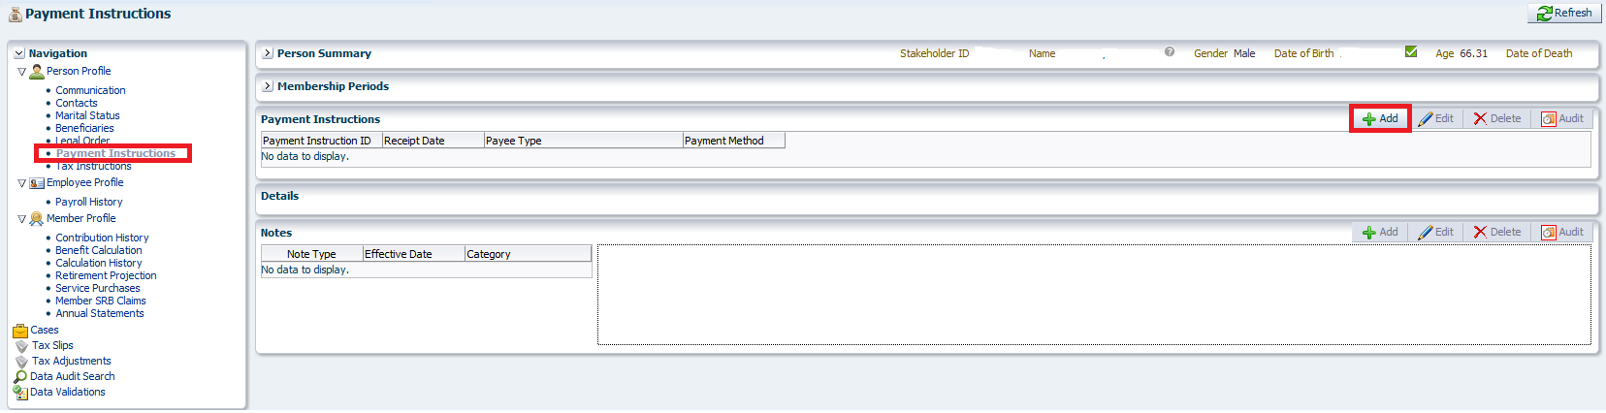

Step 5: Verify whether the data is populated in the mandatory fields and hit the save button

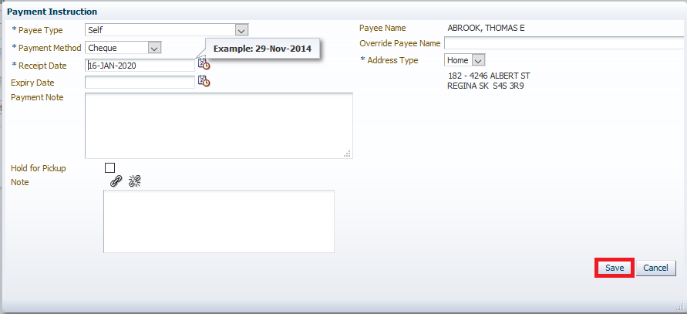

Step 6: Navigate to the benefit calculation tab

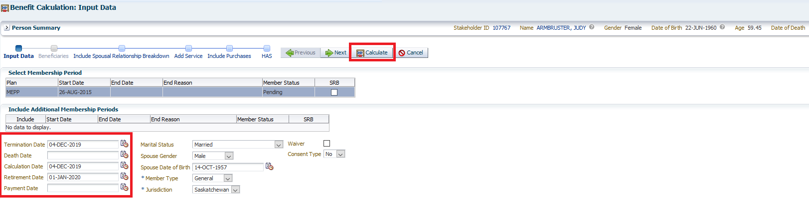

*Termination date and Retirement date will be auto populated*

Step 7: Click on the calculate button

Step 7.1: Click on the input data tab for the HAS and the calculated service

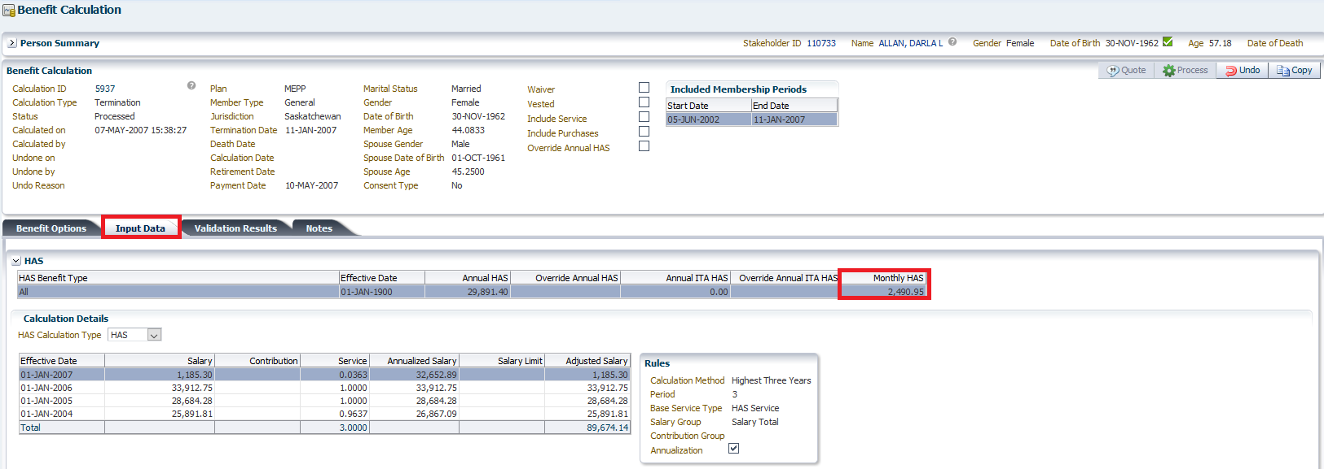

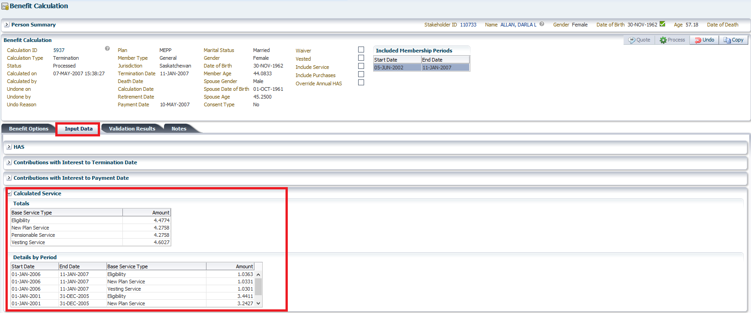

Step 8: Review the calculation details and click on the process button

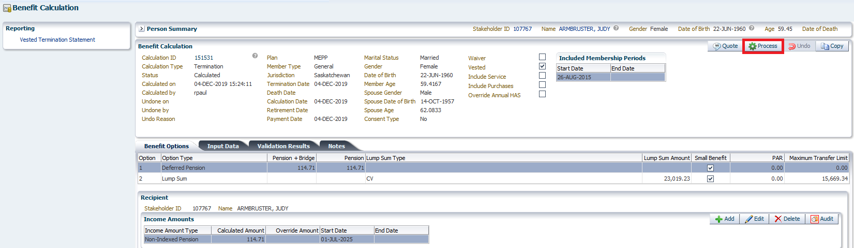

Step 9: Navigate to Benefit Selection tab from navigation pane and highlight the correct calculation if there are more than one and hit Next button

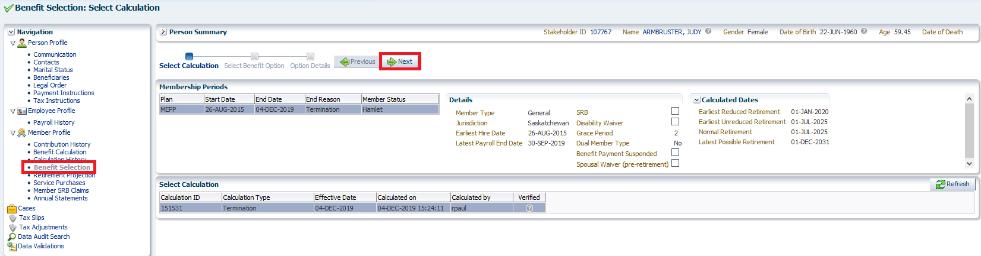

Step 10: Select the Benefit option, enter the payment date and hit next button

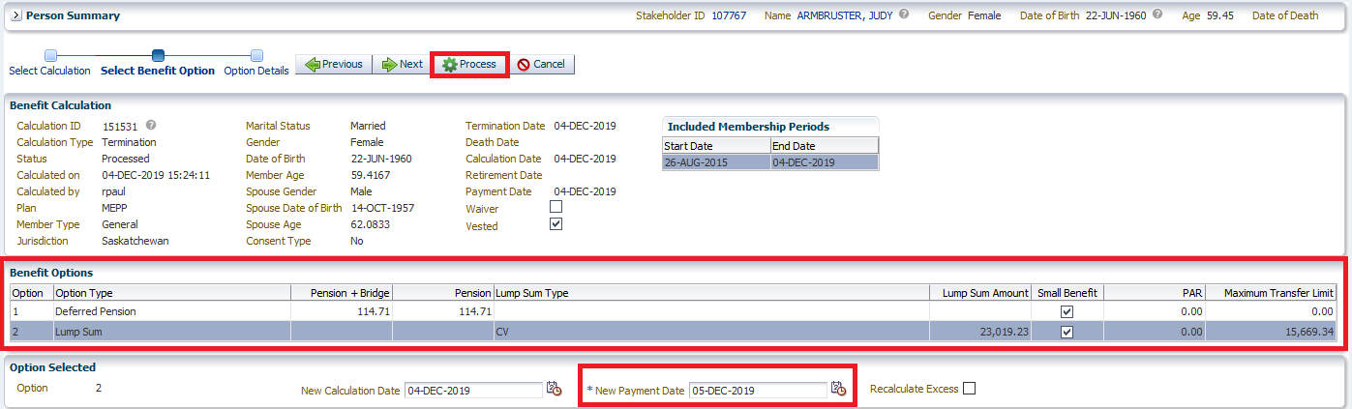

*Payment date can be any date after termination date*

Step 10: Click the Process button

Step 11: Benefits are processed and the Calculation history tab will be displayed.

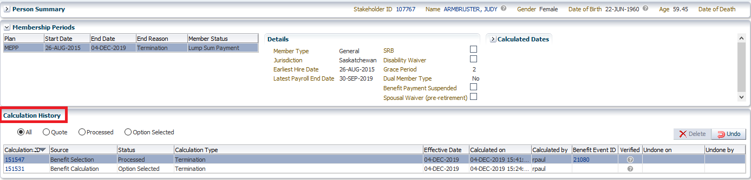

Step 12: Now from the navigation pane click on Benefit Recipient Tab

*As the benefit option selected is lump sum there is CV over limit and Small benefit amounts under onetime amount type. This amount needs to be approved separately before authorizing the payment*

Step 13: Click on the Onetime Amounts region select each onetime amount and click on submit for approval

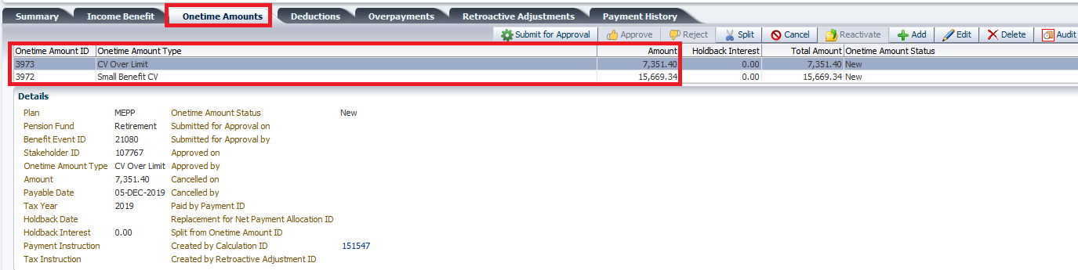

Step 14: Once two of the amounts are submitted for approval the approve button and reject button gets enabled.

Step 15: Now highlight each amount and click on approve button

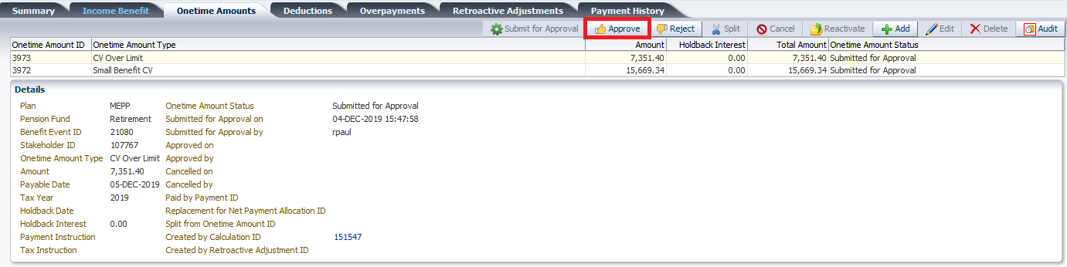

*Now both the onetime amount type has been approved*

Step 16: Go back to the summary region and hit the Authorize button

